|  |  |  |  |  |  |
| --- | --- | --- | --- | --- | --- |
| Pre-Employment |  | Periodical |  | Termination |  |

**Range of Movement**

Assess ROM and record below

|  |  |  |  |
| --- | --- | --- | --- |
| **REGION** | **MOVEMENT** | **MEASUREMENTS** | **COMMENTS** |
| Cervical | Flexion |  |  |
| Extension |  |  |
| Lateral Flexion | L: R: |  |
| Rotation | L: R: |  |
| Trunk | Extension |  |  |
| Lateral Flexion | L: R: |  |
| Shoulder | Flexion | L: R: |  |
| Abduction | L: R: |  |
| Elbow | Flexion/  Extension | L: R: |  |
| Wrist | Pronation | L: R: |  |
| Supination | L: R: |  |
| Flexion | L: R: |  |
| Extension | L: R: |  |
| Ulnar Deviation | L: R: |  |
| Radial Deviation | L: R: |  |
| Hip | Flexion | L: R: |  |
| External Rotation | L: R: |  |
| Internal Rotation | L: R: |  |
| Knee | Flexion/  Extension | L: R: |  |

**UNABLE PARTIAL ABLE COMMENT**

|  |  |  |  |  |  |  |
| --- | --- | --- | --- | --- | --- | --- |
| Ankle | ROM | Whilst sitting or standing instruct client to rotate ankle around in a circular motion | R: |  |  |  |
| L: |  |  |

**Postural Assessment**

Observe Posture and Symmetry of client

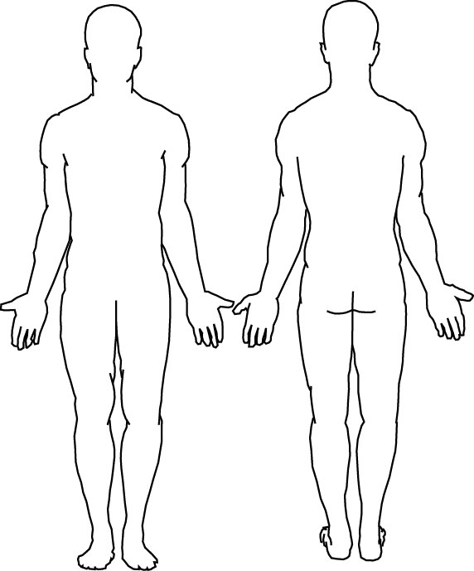OBSERVATIONS (Posterior view)

Head erect Head twisted slightly Head twisted markedly

Shoulders level One slightly elevated One markedly elevated

Spine straight Spine slightly curved Spine markedly curved

Hips level One side slightly higher One side markedly higher

Scapulae normal / protracted / retracted / elevated

OBSERVATIONS (Lateral view)

Neck straight Neck slightly forward Neck markedly forward

Chin in chin slightly out chin markedly out

Shoulders shoulders shoulders markedly

centered slightly forward forward

Upper back upper back slightly upper back markedly normally rounded rounded rounded

Lower back Lower back lower back markedly

Normally curved slightly hollow hollow

**Strength, Flexibility and Neurological Tests**

Record all Strength, Flexibility and Neurological measurements below

**Hamstring Flexibility**

**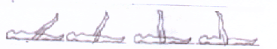 1 2 3 4 L - R -**

|  |  |  |
| --- | --- | --- |
| **PERFORMANCE** | **SCORE** (CIRCLE) | |
| Able to achieve >90o | Excellent | R = 1 L = 1 |
| Able to achieve 90o | Good | R = 0.75 L = 0.75 |
| Able to achieve 70o | Fair | R = 0.5 L = 0.5 |
| Able to achieve <70o | Poor | R = 0.25 L = 0.25 |

**Sit and Reach- Flexibility test**

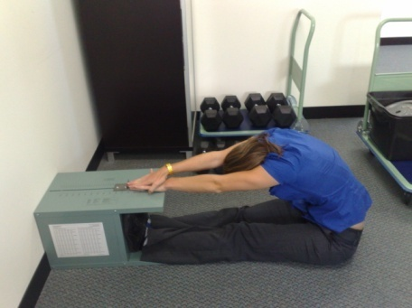Client is to sit on floor and place feet squarely against box with feet no wider than 8 inches apart. Toes should point to ceiling and knees should remain extended throughout the test. Hands are placed on top of each other, palms down with fingertips matching. The client then pushes the finger plate as far as possible. Tester must ensure no lunging, bobbing or forced assistance occurs during the test. Stretch must be held for one second and best score of three trials is recorded and applied to the relevant flexibility table.

|  |  |  |
| --- | --- | --- |
| **TRIAL** | **MEASUREMENT** | **COMMENTS** |
| 1 |  |  |
| 2 |  |
| 3 |  |
| Score | cm |
| Rating |  |

**Scoring Table for Sit and Reach Flexibility Test (cm) Circle appropriate score** **Age:**

|  |  |  |  |  |  |
| --- | --- | --- | --- | --- | --- |
| **CATEGORY**  **SEX** | **20-29**  **M F** | **30-39**  **M F** | **40-49**  **M F** | **50-59**  **M F** | **60-69**  **M F** |
| **Excellent (2)** | **31-37 34-38** | **30-35 33-38** | **26-32 31-35** | **25-32 30-36** | **22-30 28-32** |
| **Good (1.5)** | **27-30 30-33** | **25-29 29-32** | **21-25 27-30** | **21-24 27-29** | **17-21 24-27** |
| **Fair (1)** | **22-26 25-29** | **20-24 24-28** | **15-20 22-26** | **13-20 22-26** | **12-16 20-23** |
| **Poor (0.5)** | **≤21 ≤24** | **≤19 ≤23** | **≤14 ≤21** | **≤12 ≤21** | **≤11 ≤19** |

**Upper Limb Testing**

|  |  |  |
| --- | --- | --- |
| **TEST** | **COMMENTS** | **ILLUSTRATION** |
| Resistance Testing of the Wrist to Extension | No Pain/Discomfort  Pain/Discomfort | **M:\Policies and Procedures\Pre Employment Medicals\DSC_0020.JPG** |
| Resistance Testing of the Wrist to Flexion | No Pain/Discomfort  Pain/Discomfort | **M:\Policies and Procedures\Pre Employment Medicals\DSC_0016.JPG** |
| Resistance Testing of the Shoulder to Adduction | No Pain/Discomfort  Pain/Discomfort | **M:\Policies and Procedures\Pre Employment Medicals\DSC_0026.JPG** |
| Resistance Testing of the Shoulder to Abduction | No Pain/Discomfort  Pain/Discomfort | **M:\Policies and Procedures\Pre Employment Medicals\DSC_0029.JPG** |

**\* Pictures showing examiner behind client are purely for illustration purposes, actual tests are performed in front of client to observe any facial expressions**

* **Special Tests for the shoulder (If warranted)**

|  |  |
| --- | --- |
| **TEST** | **COMMENTS** |
| Resistance to Internal rotation | No Pain/Discomfort  Pain/Discomfort |
| Resistance to external rotation | No Pain/Discomfort  Pain/Discomfort |
| Supraspinatous “empty can” test | No Pain/Discomfort  Pain/Discomfort |
| “Full can” test | No Pain/Discomfort  Pain/Discomfort |
| Hawkins Kennedy test | No Pain/Discomfort  Pain/Discomfort |
| Apprehension test | No Pain/Discomfort  Pain/Discomfort |

**6-MIN WALK TEST: each two lengths walked = 50m**

(Healthy individuals range from 400-700m)

|  |  |  |  |  |  |
| --- | --- | --- | --- | --- | --- |
| **Time** | **HR prior to commencing** | **2 min** | **4 min** | **6 min** | **Recovery**  **1 min** |
| **HR** |  |  |  |  |  |
| **COMMENTS** | Recovery | | | | |

Age predicted max HR:

(220 – Age)

85% max HR: bpm

**Total Distance:**

|  |  |
| --- | --- |
| **SCORE** | **DISTANCE** |
| **EXCELLENT (4)** | **750-1000m** |
| **GOOD (3)** | **500-750m** |
| **AVERAGE (2)** | **250-500m** |
| **POOR (1)** | **<250m** |

**Grip Strength**

Client is to sit comfortably with shoulder adducted and neutrally rotated. The elbow should be flexed at 90°. The forearm and wrist should be in a neutral position. Place the hand dynamometer in the client’s hand. Instruct the client to provide maximal grip force without rapid wrenching or jerking. A 0°-30° wrist extension is allowed while grip force is being achieved. Clients exceeding 30° should be noted. Test each hand 3 times and record the mean. **Age:**

|  |  |  |  |
| --- | --- | --- | --- |
| **TRIAL** | **RIGHT HAND** | **LEFT HAND** | **COMMENTS** |
| **1** |  |  | Above Normal Range  Within Normal Range  Below Normal Range |
| **2** |  |  |
| **3** |  |  |
| **AVERAGE** |  |  |
| **NORMAL RANGE** | ( kg) | ( kg) |

|  |  |  |  |
| --- | --- | --- | --- |
| Abduction | Instruct client to hold arms to the side, keeping arms straight just above shoulder height for a maximum of  **1 minute** | **UNABLE PARTIAL ABLE** (circle)  No Pain/Discomfort | **M:\REDIMED\REHABILITATION\Photo's\DSC_0162.JPG** |
| Sustained Squat | Instruct client to perform a Deep squat to floor, hold for 60 seconds, then duck walk 1m forward and repeat back | **UNABLE PARTIAL ABLE** (circle)  No Pain/Discomfort | |
| Sustained Kneel | Instruct client to kneel on the ground and hold for 30 seconds | **UNABLE PARTIAL ABLE** (circle)  No Pain/Discomfort | |
| Repetitive  Lunges | Instruct client to stand with feet together and arms by side. Step forward with one leg and lower upper body down by bending leg, ensuring knees do not go over toes and back is kept straight. Push up and back and repeat with the other leg. | **UNABLE PARTIAL ABLE** (circle)  No Pain/Discomfort | |
| Single Leg Balance | Instruct client to stand with both feet and then slowly raise one of the feet off the ground and hold the position for 30s. Repeat for the other leg | **UNABLE PARTIAL ABLE** (circle)  No Pain/Discomfort | |

**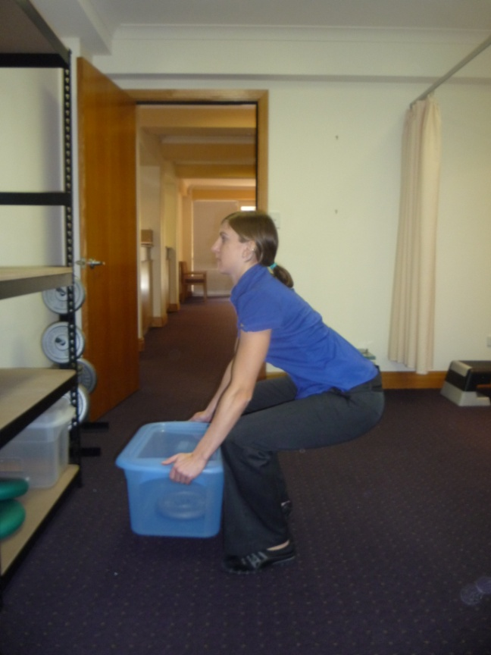Functional Task Assessment**

(Please refer to Job description guide for specific tolerances for each job title)

E**ach exercise performed STRONGLY and CONSISTANTLY**. **Tester demonstrates correct technique prior to each exercise**

**Prior to functional tasks, ensure client stretches to help prevent injury**

**Client only progresses to heavier loads if the load is within their limit and they are demonstrating GOOD technique**

**Things to consider whilst client performs activity and noting down in COMMENT SECTION**

**PAIN SCALE (1-10) 1 – Experiencing NO Pain……10 – Experiencing Severe Pain**

|  |  |
| --- | --- |
| **NEAR-MAXIMAL EFFORT** | |
| * Accessory Muscles * Post Trunk Lean | * Vertical Trunk Alignment Decreases * Hands Slip/Difficulty Holding Box * Decreased Box Control |

**Score Scale for Repetitive Lifting Exercises performed up to a maximum of 10 times**

|  |  |  |
| --- | --- | --- |
| **PERFORMANCE** | **FITNESS** | **SCORE** |
| Very strong execution of exercise, met 100% of Job Requirement | Excellent | 4 |
| Very strong execution of exercise, met 75% of Job Requirement | Good | 3 |
| Very strong execution of exercise, met 50% of Job Requirement | Fair | 2 |
| Very strong execution of exercise, met 25% of Job Requirement | Poor | 1 |

**Task – Floor to Waist Job Demand: 10 kgs**

Instruct client to stand up straight with feet shoulder width apart. Bend knees and pick up crate from floor grasping handles. Ensure knees do not go over toes and back is kept straight. Then resume to standing position and put crate on shelf. If repetition is completed without pain, add 5kg with each successful repetition performed until 10kg is achieved pain-free, once achieved perform the remainder of the repetitions at 10kg

|  |  |  |  |  |
| --- | --- | --- | --- | --- |
| **REP** | **WEIGHT** | **PAIN/LOCATION** | **COMMENTS FOLLOWING FEEDBACK** | |
| **1** |  |  | **UNABLE PARTIAL ABLE** (circle)  No Pain/Discomfort  Manual Handling Technique following Feedback:  Good Average Poor  Client’s Limit Reached | Kept load close to body  Yes No  Kept a neutral spine Yes No  Demonstrated Good  Squat position to lift load Yes No  Avoids trunk rotation  Yes No  Demonstrates good  Base of support  Yes No |
| **2** |  |  |
| **3** |  |  |
| **4** |  |  |
| **5** |  |  |
| **6** |  |  |
| **7** |  |  |
| **8** |  |  |
| **9** |  |  |
| **10** |  |  |
| **Managed kg** | | | | | |

**Task –** Carrying at **Waist** **Height Job Demand: 10kgs** up to **30m**

Instruct client to stand up straight with feet shoulder width apart and pick up crate from shelf grasping handles. Client carries load for distance of 20m.

|  |  |  |  |  |
| --- | --- | --- | --- | --- |
| **REP** | **WEIGHT** | **PAIN/LOCATION** | **UNABLE PARTIAL ABLE** (circle)  No Pain/Discomfort | **COMMENTS** |
| **1** |  |  | Manual Handling Technique  Good Average Poor  Client’s Limit Reached  Excessive Post trunk Lean Yes  No |
| **2** |  |  |
| **3** |  |  |

**HR:**

**Dynamic Push/Pull**

Load wheelbarrow with relevant weight. Ask client to pull wheelbarrow, ensuring that you observe backwards movements.

|  |  |  |  |  |
| --- | --- | --- | --- | --- |
| **PUSHING/ PULLING TYPE** | **EXPLANATION** | **SCORE** | **MAX WEIGHT REQUIRED** | **TRIAL 1- 100 METRES** |
| Bilateral Pulling and Pushing  Waist Level | Instruct client to face wheelbarrow, grasp handles with both hands and pull wheelbarrow towards them whilst walking backwards. Then repeat whilst pushing instead. |  | 80kgs | **UNABLE PARTIAL ABLE** (circle)  No Pain/Discomfort  Controlled Movement  Symmetrical Movement |
|  | **COMMENTS:** | | | |

**Manual Handling Technique**

|  |  |  |
| --- | --- | --- |
| **CATEGORIES** | **SCORE** | **COMMENTS** |
| Kept load close to body | /1 |  |
| Kept a neutral spine and avoided trunk rotation | /1 |  |
| Demonstrated Good Squat position to lift load | /1 |  |
| Demonstrates good Base of support | /1 |  |

**NOTE: Please ensure client has removed Heart Rate Monitor before leaving**

**FUNCTIONAL ASSESSMENT**

**RESULTS**

|  |  |  |
| --- | --- | --- |
| **CATEGORIES** | **SCORE** | **RATING** |
| Flexibility (back, hamstrings) | /4 |  |
| Muscular Endurance/ Strength | /8 |
| Cardiovascular Fitness | /4 |

|  |  |
| --- | --- |
| **RATING SYSTEM** | |
| **SCORE** | **RATING** |
| **13-16** | **GOOD** |
| **9-12** | **SATISFACTORY** |
| **0-8** | **UNSATISFACTORY** |

**Total Score: /16**

**Rating:**

**OVERALL COMMENTS**

**Isolated Hamstring Flexibility - Sit and Reach Flexibility - 6 Minute Walk Test - Functional Task Assessment -**

**Assessed by:**

**Name:**

**Signed:**

**Date: / /2012**